003.1 npm - pretask posttask

NPM Kata List – Blog Page

[NPM Kata List on GitHub](https://github.com/robertdunaway/katas-gulp)

# Duration

5 minutes

# Brief

[subject of kata]

### For More Information

BING/GOOGLE: “NPM pretask posttask”

# Instructions

Get tutorial folder or the entire katas-npm repo.

Open the [before/*.sln] file and execute the kata.

Feel free to execute this kata multiple times because repetition creates motor memory.

# Github

* Before (start kata with this)
  + https://github.com/robertdunaway/katas-npm/tree/master/003.1%20npm%20-%20pretask%20posttask/before
* After
  + https://github.com/robertdunaway/katas-npm/tree/master/003.1%20npm%20-%20pretask%20posttask/after

# Kata

Create tasks that automatically run before and after a task you execute.

These tasks can simply call task_with_name.js function. This will output the name of the task that executed so it will be easier to follow what is happening.

The provided tasks will help. The timer.js provides a time stamp used by the task_with_name.js file. The task_with_name.js file derives and outputs the name of the task that executed it.

# Review

NPM has predefined tasks such as pre[task-name] and post[task-name].

Prepending a task with pre or post causes the task to run before or after the target task.

First let’s create two simple tasks.

task1

var timer = require('./timer.js');

timer("task1");

task2.js

var timer = require('./timer.js');

timer("task2");

Update package.json to execute tasks1 and task2.

{

"name": "npm",

"version": "1.0.0",

"description": "",

"dependencies" : {

"minimist": "latest"

},

"main": "index.js",

"scripts": {

"task1": "node npm-scripts/task1.js",

"task2": "node npm-scripts/task2.js"

},

"author": "",

"license": "ISC",

"devDependencies": {

"date-and-time": "^0.3.0"

}

}

Execute task1

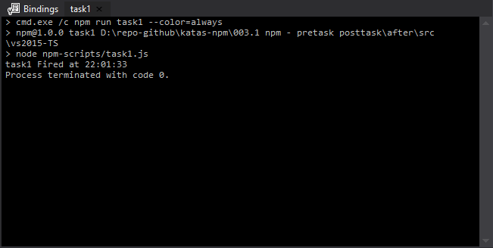

Add a pre and post task to package.json.

"pretask1": "node npm-scripts/task_with_name.js",

"task1": "node npm-scripts/task1.js",

"posttask1": "node npm-scripts/task_with_name.js",

"task2": "node npm-scripts/task2.js"

Now execute task1.

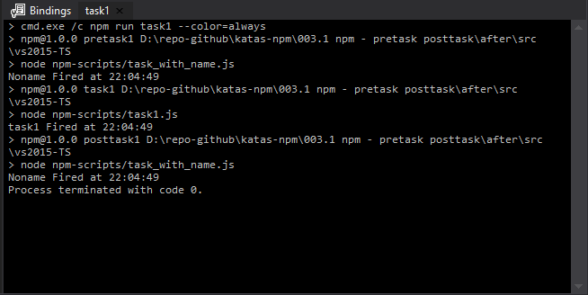

# Next

Take a few minutes and imagine more examples.